Predicting 30-Day Hospital Readmission in Diabetic Patients: A Comparison of Traditional Machine Learning and Deep Learning
[Your Full Name], [Student ID], [Module Name], [Institution], 18 October 2026
GitHub: https://github.com/acele-happy/Summative-ModelTrainingAndEvaluation
Google Drive (raw data zip and saved models; set to Anyone with the link can view): [paste link]
Video presentation (5–10 minutes): [paste link]
Items in red are the only fields that still have to be filled by hand before submission. Every experimental number below comes from the executed notebook.
Abstract
Unplanned hospital readmission within 30 days of discharge is a costly and widely monitored outcome for patients with diabetes. This paper compares traditional machine learning and deep learning for predicting that outcome from the Diabetes 130-US Hospitals dataset (101,766 encounters from 71,518 patients, 1999–2008). After deaths, hospice discharges and repeat encounters were removed, 69,987 encounters remained, of which 8.98% (6,285) were readmitted within 30 days. Logistic regression, support vector machines, a random forest and histogram gradient boosting were trained and, except for the kernel SVM, tuned by randomized search. Sequential and residual networks were trained with a tf.data pipeline, class weights and early stopping. On 13,998 held-out encounters the tuned random forest reached a ROC-AUC of 0.656 (95% confidence interval 0.640–0.673) and a PR-AUC of 0.179. The best network, a residual multilayer perceptron, reached 0.652 (0.636–0.670) and 0.165. Feature engineering raised cross-validated ROC-AUC by only 0.002 to 0.006. Predictions are dominated by discharge destination: patients sent home are often missed, and patients transferred to a facility are flagged almost indiscriminately. The ceiling matches published readmission models and points to the information available at discharge, rather than to model complexity.
Index Terms—hospital readmission, diabetes, class imbalance, random forest, gradient boosting, deep learning, tabular data, clinical prediction.
I. Introduction
Diabetes is among the most common chronic conditions in hospital, and patients with diabetes are readmitted more often than the general inpatient population. A return within 30 days is distressing for patients and expensive for health systems, and the 30-day rate is a long-standing marker of discharge planning [1], [2]. If the patients most likely to return could be identified at discharge, scarce follow-up, such as a transition call or an early clinic visit, could be aimed at them.
Predicting readmission is nevertheless a difficult machine learning problem. The outcome is the product of clinical, social and behavioural factors that are only partly recorded in administrative and hospital data. The positive class is rare, so a naive classifier can achieve high accuracy by predicting that nobody returns. Records are heterogeneous, mixing counts, ordinal age brackets, high-cardinality diagnosis codes and medication-change flags. In addition, many patients contribute several encounters. If those encounters are split across the training and test sets, a model can exploit patient-specific patterns that would not be available for a genuinely new patient, which inflates reported performance [3].
This project addresses these challenges with the Diabetes 130-US Hospitals dataset from the UCI Machine Learning Repository [4]. The task is binary classification: given information available when a patient is discharged, predict whether that patient will be readmitted in fewer than 30 days. Three research questions guide the study. First, how do well-tuned traditional algorithms compare with one another on this task? Second, does clinically motivated feature engineering improve performance beyond the raw columns? Third, can neural networks built with the TensorFlow and Keras Sequential and Functional APIs outperform tuned traditional models on this tabular problem, and what do learning curves and error analysis reveal about the limits of each approach?
The contributions are a leakage-aware preprocessing pipeline that retains one encounter per patient and removes patients who cannot be readmitted; a controlled ablation of engineered features across several model families; a comparison of tuned scikit-learn models with Sequential and residual networks trained through a tf.data pipeline under one evaluation protocol; and an error analysis by age, primary diagnosis and discharge destination, together with permutation importance.
II. Literature Review
The dataset used here was introduced by Strack et al. [5], who extracted 101,766 inpatient encounters of patients with diabetes from 130 US hospitals over ten years. Their primary interest was clinical rather than predictive. Using logistic regression on roughly 70,000 records, they reported that measurement of HbA1c during the admission was associated with a lower readmission rate, and that the association depended on the primary diagnosis. The study also established preprocessing conventions that later work has borrowed, including the grouping of ICD-9 diagnosis codes into a small number of clinical categories and the exclusion of encounters that end in death or hospice discharge. Those conventions are followed here.
The broader readmission literature has consistently reported modest discrimination. A systematic review by Kansagara et al. [6] examined 26 validated models and found that most achieved c-statistics between about 0.55 and 0.65, with only a minority, mostly those using richer clinical data, approaching 0.70 or above. Jencks et al. [1] documented the scale of rehospitalisation in Medicare populations and noted that a large share of returns occur without a clear clinical plan, which is the practical motivation for a prediction-guided intervention. These findings set the expectation for the present study: a model that uses only discharge-time administrative and laboratory summaries should not be expected to separate readmitted from non-readmitted patients with high accuracy.
Deep learning is strong when the input is a long, time-stamped record. Rajkomar et al. [7] trained sequence models on the longitudinal charts of hundreds of thousands of patients and improved prediction of mortality, readmission and length of stay relative to logistic regression. A single summary row is a different problem. On medium-sized tables, Shwartz-Ziv and Armon [8] found that tuned gradient boosting matched or beat recent deep architectures, and Grinsztajn et al. [9] argued that trees remain state of the art because they ignore weak features and represent irregular rules. Gorishniy et al. [10] showed that regularised multilayer perceptrons and ResNet-like models are competitive baselines even when they do not win. Both a Sequential network and a residual perceptron are therefore compared here with tuned tree ensembles, not only with an untuned linear model.
When the positive class is rare, the choice of curve matters. Davis and Goadrich [11] and Saito and Rehmsmeier [12] showed that precision–recall plots are more informative than ROC plots under imbalance, so both ROC-AUC and PR-AUC are reported and the threshold is chosen explicitly. Kaufman et al. [3] identified repeated measurements of the same entity in the training and test sets as a standard form of leakage. That warning applies here, because 71,518 patients account for 101,766 encounters. Clinical scores can also shift resources between groups [13]. This study is not a formal fairness audit, but it does report recall and false-positive rate by age, primary diagnosis and discharge destination.
III. Methodology
A. Dataset
The Diabetes 130-US Hospitals for Years 1999–2008 dataset is distributed by the UCI Machine Learning Repository [4]. Each row is one hospital encounter of a patient with diabetes who stayed between one and fourteen days. The raw file contains 101,766 rows and 50 columns, which meets the requirement of at least 20,000 rows, and it covers 71,518 distinct patients. The columns record demographics, admission and discharge codes, length of stay, payer, medical specialty, procedure and medication counts, prior-year outpatient, emergency and inpatient visits, three ICD-9 codes, glucose and HbA1c results where measured, and 23 diabetes-medication flags. The original target has three levels: no recorded readmission (54,864 encounters, 53.9%), readmission after more than 30 days (35,545, 34.9%) and readmission within 30 days (11,357, 11.2%).
Missingness is severe in several columns. Weight is missing for 96.9% of rows, glucose serum for 94.7%, HbA1c for 83.3%, medical specialty for 49.1% and payer code for 39.6%. Race is missing for 2.2%. The raw file is not in the GitHub repository. The notebook downloads it from UCI, and the zipped file belongs in the project Google Drive folder.
B. Target Definition and Cleaning
The positive class is readmission within 30 days. The other two original labels form the negative class, because early readmission is the outcome discharge interventions are meant to prevent. Encounters ending in death or hospice (disposition codes 11, 13, 14, 19, 20 and 21) were removed, since those patients cannot be readmitted; 99,343 encounters remained. Three rows with gender recorded as Unknown/Invalid were removed. Only the earliest encounter of each patient was then kept, using the encounter identifier as a chronological proxy. That step removed 29,353 later stays and left 69,987 rows. Without it, the same patient could appear in both partitions and the model could learn an identity rather than a risk pattern [3]. Weight, the two identifiers and three constant medication columns (examide, citoglipton and glimepiride-pioglitazone) were dropped. Remaining missing categorical values were coded as an explicit Missing level, because a missing specialty or payer can itself be informative. The modelling table has 44 columns, including the target, and a positive rate of 8.98% (6,285 patients). The rate is lower than the raw 11.2% because patients with several encounters are more likely to have a later early readmission, and only the first stay is kept. Table I summarises the reduction.
TABLE I. Dataset size and positive rate at each cleaning stage
Stage | Rows | Columns | Positive rate (<30 days)
Raw data | 101,766 | 50 | 11.16% (11,357)
After removing expired and hospice discharges | 99,343 | 50 | 11.39%
After removing invalid gender | 99,340 | 50 | 11.39%
One encounter per patient (modelling table) | 69,987 | 44 | 8.98% (6,285)

C. Feature Engineering
Two feature sets isolate the effect of feature engineering. The base set has eight numeric counts, including length of stay and prior visits, plus demographics, administrative codes, the two laboratory results, the change and diabetesMed flags, and the non-constant medication columns. Admission type, discharge disposition and admission source are categories, not magnitudes. Raw ICD-9 codes are excluded because several hundred levels per column would dominate a one-hot encoding. The engineered set adds nine variables, all computed from the same row. Following Strack et al. [5], each diagnosis code is mapped to one of nine clinical groups, with a level for missing codes. Age is converted to the midpoint of its bracket. Total prior visits sum the three prior-year visit counts. Further columns count dose changes, count active diabetes drugs, and express medications and laboratory procedures per day of stay. The base set has 40 columns and the engineered set has 49. Fig. 1 shows why age and prior utilisation are plausible inputs: the early-readmission rate rises from about 2% in the youngest bracket to about 10% in the eighth and ninth decades, and from under 10% with no prior inpatient stay to above 30% when there were five or more.
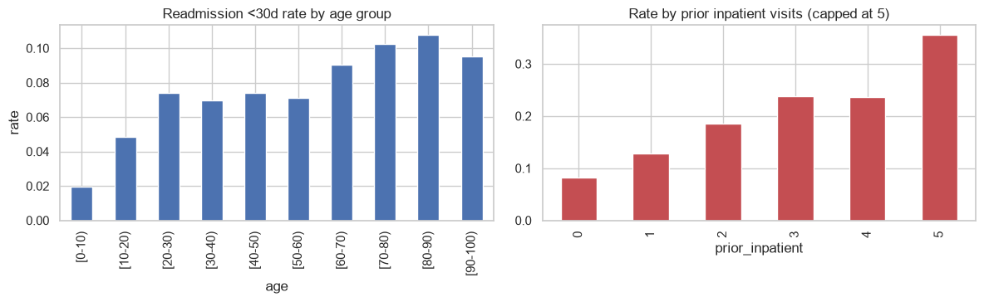
Fig. 1. Early-readmission rate after cleaning, by age bracket (left) and by the number of inpatient visits in the previous year, capped at five (right).
D. Partitioning and Preprocessing
The cleaned table was split into a training set of 55,989 encounters (80%) and a test set of 13,998 encounters (20%) with stratified sampling and random seed 42. Both partitions have a positive rate of 9.0%; the test set contains 1,257 positive encounters and 12,741 negative encounters. The test set was not used for model selection, threshold choice or architecture choice. Traditional model selection used stratified three-fold cross-validation on the training set. The neural networks used a further stratified split of that training set into 47,590 training rows (85%) and a validation set of 8,399 rows (15%).
Preprocessing was placed inside a scikit-learn pipeline [14] so that it was fitted only on the rows of the current training fold. Numeric columns were median-imputed and standardised. Categorical columns were one-hot encoded, and any level occurring fewer than 100 times in the fit data was collapsed into a single infrequent bucket, which limits dimensionality and stops the model memorising rare codes. For the neural networks the same transformer was fitted on the 47,590-row subset only and then applied to validation and test, producing a dense matrix of 195 columns.
E. Traditional Models
Five scikit-learn algorithms were compared [14]. Logistic regression and a linear support vector machine [15], the latter wrapped in probability calibration, were the linear models. A radial-basis-function support vector machine was trained only on a stratified subsample of 12,000 rows, because kernel SVM training time grows poorly with sample size; that result is not treated as interchangeable with the others. A random forest [16] represented bagged trees, and histogram gradient boosting, following LightGBM [17] and Friedman [18], represented boosted trees. All four full-data models used class weighting. Each was cross-validated on both feature sets before any search, so the ablation is not confounded with tuning.
F. Hyperparameter Search
Hyperparameters of logistic regression, the random forest and histogram gradient boosting were tuned on the engineered feature set with randomized search [19]. The objective was ROC-AUC under the same three-fold stratified cross-validation, and the winning configuration of each family was refitted on the full training set. Logistic regression has a single free parameter in this search, so its five values were evaluated exhaustively. The forest and the boosting model were each given 12 random draws from the spaces in Table II. The linear SVM was not included in the search because calibration inside every candidate would have multiplied the cost, and the RBF SVM was already restricted to a subsample.
TABLE II. Hyperparameter search spaces for the traditional models
Model | Hyperparameter | Values searched | Draws
Logistic regression | Inverse regularisation C | 0.001, 0.01, 0.1, 1, 10 | 5 (all)
Random forest | Number of trees | 200, 300, 500 | 12
Random forest | Maximum depth | 8, 12, 16, unlimited | 12
Random forest | Minimum samples per leaf | 3, 5, 10, 20 | 12
Random forest | Features considered per split | square root, 30% | 12
Gradient boosting | Learning rate | 0.02, 0.05, 0.1 | 12
Gradient boosting | Maximum depth | 3, 5, unlimited | 12
Gradient boosting | Maximum leaf nodes | 15, 31, 63 | 12
Gradient boosting | Minimum samples per leaf | 20, 50, 100 | 12
Gradient boosting | L2 regularisation | 0, 1, 10 | 12
Gradient boosting | Boosting iterations | 200, 400 | 12

G. Deep Learning Models
The networks were implemented in TensorFlow 2.21 and Keras [20]. A tf.data pipeline shuffles the training rows each epoch, batches them in groups of 256 and prefetches the next batch. Balanced class weights on the network training subset were 0.549 for the negative class and 5.567 for the positive class. Sequential models stack dense ReLU layers, each followed by batch normalisation [21] and dropout [22], and end in a sigmoid unit. The Functional-API model is a residual multilayer perceptron: each block adds a dense, batch-normalised, dropped-out residual back to its input [23]. That skip connection cannot be written with the Sequential API. Every network used Adam [24], binary cross-entropy and L2 penalties on the dense kernels. Training ran for at most 60 epochs, with early stopping on validation ROC-AUC (patience of eight epochs, best weights restored) and a learning rate that halved after three epochs without improvement, down to 1e-5. The five configurations in Table III vary width, depth, dropout, L2 and learning rate. The highest validation ROC-AUC was kept and scored once on the test set.
TABLE III. Deep learning configurations that were trained
Configuration | API | Hidden structure | Dropout | L2 | Learning rate
Sequential-64 | Sequential | 64 | 0.2 | 1e-4 | 1e-3
Sequential-128-64 | Sequential | 128, then 64 | 0.3 | 1e-4 | 1e-3
Sequential-256-128-64 | Sequential | 256, 128, then 64 | 0.4 | 1e-3 | 5e-4
Residual-128x2 | Functional | width 128, 2 residual blocks | 0.3 | 1e-4 | 1e-3
Residual-256x3 | Functional | width 256, 3 residual blocks | 0.4 | 1e-3 | 5e-4

H. Evaluation Protocol
Accuracy was not a selection metric. At a 9% positive rate, a classifier that never predicts readmission is already about 91% accurate. Ranking quality was measured by ROC-AUC and PR-AUC. Precision, recall, F1 and F2 were computed at a threshold chosen to maximise F2, which weights recall twice as heavily as precision, on the judgement that a missed early readmission costs more than an extra follow-up call. Traditional thresholds came from out-of-fold training predictions, and the network threshold came from the validation set, so the test set was scored only after the threshold was fixed. Test ROC-AUC uncertainty used 500 bootstrap resamples. Learning curves, confusion matrices and ROC and precision–recall curves were inspected. Errors of the selected traditional model were broken down by age, primary diagnosis and discharge disposition, and permutation importance was estimated on 6,000 test rows with five repeats.
IV. Results
A. Baselines and the Feature-Engineering Ablation
Table IV reports three-fold cross-validated scores before tuning. On the engineered features, histogram gradient boosting leads (ROC-AUC 0.6533 ± 0.0062, PR-AUC 0.1665), followed by the random forest (0.6525 ± 0.0056, PR-AUC 0.1703), the calibrated linear SVM (0.6458 ± 0.0056) and logistic regression (0.6454 ± 0.0056). A no-skill PR-AUC would equal the positive rate, about 0.090, so every model ranks better than chance and none ranks well. The RBF SVM, fit on 12,000 rows, reached only 0.6155 ± 0.0119 and is not a fair competitor.
Feature engineering raised ROC-AUC for every full-data model, by 0.0019 for logistic regression, 0.0021 for the linear SVM, 0.0035 for the forest and 0.0058 for gradient boosting. The mean gain is 0.0033. The fold standard deviation is about 0.006, so the largest gain is comparable to the noise of the estimate. The direction is consistent, which supports a small effect, and Fig. 2 shows that every bar remains well below 0.70.
TABLE IV. Three-fold cross-validated performance before hyperparameter search
Model | Features | ROC-AUC (mean ± SD) | PR-AUC
Logistic regression | Base | 0.6435 ± 0.0066 | 0.1631
Logistic regression | Engineered | 0.6454 ± 0.0056 | 0.1650
Linear SVM (calibrated) | Base | 0.6437 ± 0.0065 | 0.1627
Linear SVM (calibrated) | Engineered | 0.6458 ± 0.0056 | 0.1644
Random forest | Base | 0.6490 ± 0.0056 | 0.1695
Random forest | Engineered | 0.6525 ± 0.0056 | 0.1703
Gradient boosting | Base | 0.6475 ± 0.0063 | 0.1689
Gradient boosting | Engineered | 0.6533 ± 0.0062 | 0.1665
RBF SVM (12,000-row subsample) | Engineered | 0.6155 ± 0.0119 | 0.1371

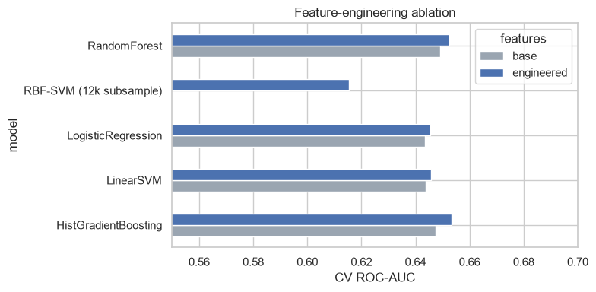
Fig. 2. Cross-validated ROC-AUC on the base feature set and on the engineered feature set. The RBF SVM was fit only on the engineered set, using 12,000 training rows.
B. Hyperparameter Tuning
Randomized search moved the scores only slightly, which is what a feature-imposed ceiling would look like. Logistic regression rose from 0.6454 to 0.6471 at C = 0.01, stronger shrinkage than the default. The forest rose from 0.6525 to 0.6552 with 500 trees, unlimited depth, a minimum of 10 samples per leaf and the square root feature rule. Gradient boosting rose from 0.6533 to 0.6539 at a learning rate of 0.05, unlimited depth, 31 leaves, a minimum of 100 samples per leaf, 400 iterations and no L2 penalty. The forest had the best cross-validated ROC-AUC and was used for the learning curve, the threshold and the error analysis. Table V collects the comparison. Stronger shrinkage and larger leaves both helped, which fits a weak signal.
TABLE V. Cross-validated ROC-AUC before and after tuning, engineered features
Model | ROC-AUC before | ROC-AUC after | Selected parameters
Logistic regression | 0.6454 | 0.6471 | C = 0.01
Random forest | 0.6525 | 0.6552 | 500 trees; depth unlimited; min. leaf 10; max. features = sqrt
Gradient boosting | 0.6533 | 0.6539 | learning rate 0.05; depth unlimited; 31 leaves; min. leaf 100; 400 iterations; L2 = 0

C. Learning Curves
Fig. 3 is the learning curve of the selected forest. Because it is estimated inside three-fold cross-validation, the horizontal axis stops near 37,000 examples, the number of rows inside a fold, rather than at the full 55,989. Training ROC-AUC stays between about 0.98 and 0.99. Validation ROC-AUC starts near 0.61, reaches about 0.64 by roughly 10,000 examples, and is nearly flat at about 0.65 at the right-hand edge. The gap of about 0.33 shows that unlimited depth still fits each training fold. The validation curve is the result that matters, and it has largely converged: more encounters with the same columns would move ROC-AUC only a little.
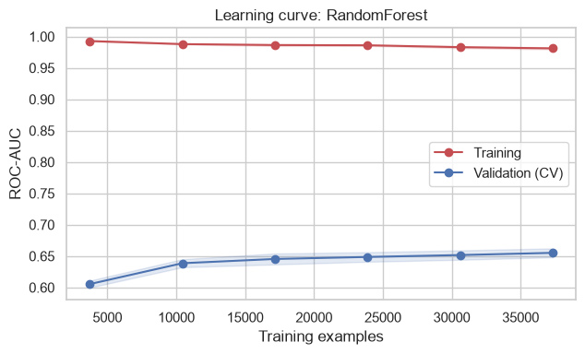
Fig. 3. Learning curve of the tuned random forest. Bands are ±1 standard deviation across the three cross-validation folds. The largest training size is the number of rows inside one fold.
Fig. 4 is the history of Residual-128x2. Training loss falls from about 0.86 to about 0.57 over 18 epochs, while validation loss reaches a noisy minimum near 0.59 and then fluctuates upward. Training ROC-AUC climbs from about 0.55 toward 0.80. Validation ROC-AUC peaks at 0.643 and does not follow. Early stopping restored the best validation weights. The ceiling matches the forest: extra capacity is absorbed by the training set, and validation remains near 0.64.
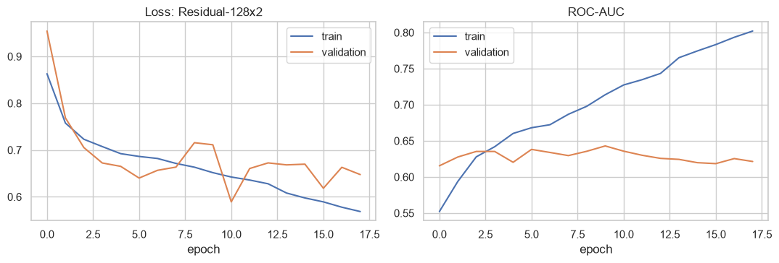
Fig. 4. Training and validation loss (left) and ROC-AUC (right) for Residual-128x2, the neural network with the highest validation ROC-AUC. Early stopping restored the best validation weights.
D. Deep Learning Experiments
Table VI shows that validation ROC-AUC spans only 0.6380 to 0.6429. Residual-128x2, with width 128, two blocks, dropout 0.3 and 59,265 parameters, is best, after 18 epochs. Residual-256x3 is tied with it (0.6428) despite 250,881 parameters. Among Sequential models the smallest is best (0.6412, 12,865 parameters) and the deepest is worst (0.6380, 25 epochs). Width and depth did not help. Residual connections improved on the Sequential stacks by only a few thousandths of ROC-AUC, which is unsurprising in networks this shallow. Validation PR-AUC stayed between 0.156 and 0.160 throughout.
TABLE VI. Validation performance of the five neural networks
Configuration | Parameters | Epochs run | Best val. ROC-AUC | Best val. PR-AUC
Residual-128x2 | 59,265 | 18 | 0.6429 | 0.1557
Residual-256x3 | 250,881 | 15 | 0.6428 | 0.1598
Sequential-64 | 12,865 | 12 | 0.6412 | 0.1588
Sequential-128-64 | 34,177 | 16 | 0.6386 | 0.1596
Sequential-256-128-64 | 93,185 | 25 | 0.6380 | 0.1564

E. Test-Set Performance
Table VII scores every tuned model once on the 13,998 test encounters. The forest reaches ROC-AUC 0.6564 (95% bootstrap interval 0.6400–0.6734) and PR-AUC 0.1792. Gradient boosting is close on ROC-AUC (0.6504) and best on PR-AUC (0.1832). Logistic regression reaches 0.6486 and 0.1686. Residual-128x2 reaches 0.6518 (interval 0.6362–0.6695) and 0.1648. The 0.0046 gap between forest and network sits inside the overlap of the intervals, so neither paradigm is shown to be superior. In Fig. 5 the ROC curves lie almost on top of one another. On the precision–recall plot every model beats the no-skill line at 0.090, and precision is already near 0.15 once recall passes one half.
The operating points show the practical weakness. At its F2 threshold of 0.322 the forest detects 854 of 1,257 early readmissions and misses 403, while raising 6,031 false alarms among 6,885 flagged patients. Precision is 0.124: about 12 of every 100 flagged patients were readmitted within 30 days, against a base rate of about 9. The network, at 0.386, detects 1,044 and misses 213 by flagging 9,657 patients, 8,613 of them incorrectly, for a precision of 0.108. Accuracy near 0.54 for the forest would be a misleading headline. Fig. 6 shows both matrices.
TABLE VII. Test-set performance at the F2-optimal threshold
Model | ROC-AUC | PR-AUC | Threshold | Precision | Recall | F1 | F2
Random forest | 0.6564 | 0.1792 | 0.322 | 0.1240 | 0.6794 | 0.2098 | 0.3584
Neural network (Residual-128x2) | 0.6518 | 0.1648 | 0.386 | 0.1081 | 0.8305 | 0.1913 | 0.3555
Gradient boosting | 0.6504 | 0.1832 | 0.437 | 0.1168 | 0.7001 | 0.2002 | 0.3502
Logistic regression | 0.6486 | 0.1686 | 0.423 | 0.1143 | 0.7621 | 0.1987 | 0.3571

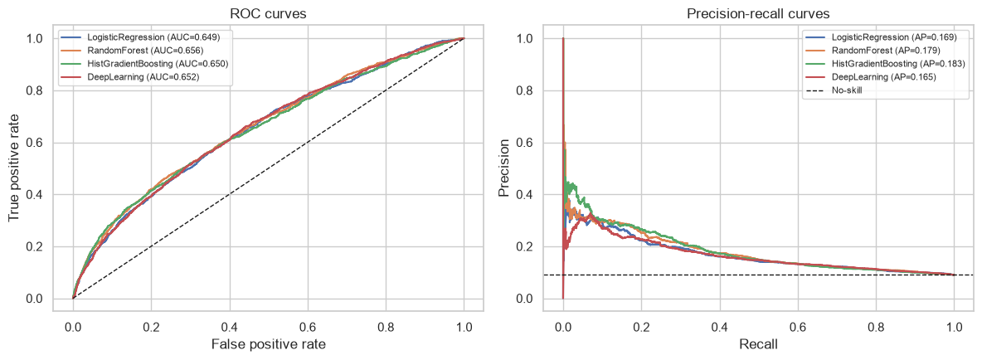
Fig. 5. Test-set ROC curves (left) and precision–recall curves (right). The dashed line on the left is chance. The dashed line on the right is a no-skill classifier at the positive rate.
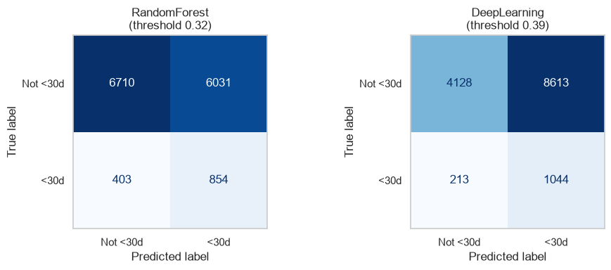
Fig. 6. Confusion matrices on the test set at the F2 thresholds. Left: tuned random forest (threshold 0.32), with 854 true positives, 403 false negatives, 6,031 false positives and 6,710 true negatives. Right: Residual-128x2 (threshold 0.39), with 1,044 true positives, 213 false negatives, 8,613 false positives and 4,128 true negatives.
F. Error Analysis and Feature Importance
Recall is not uniform (Table VIII). It is 0.468 for patients in their forties and stays near 0.49 through the fifties, then rises to 0.631, 0.775, 0.842 and 0.848 across the next four decades. The false-positive rate rises with it, from 0.292 to 0.732. The model assigns older adults a higher score in general, so one global threshold catches most early readmissions among the oldest patients and misses about half of them between ages 30 and 60. Primary diagnosis moves recall less. Injury has recall 0.839 and respiratory disease, the lowest, has 0.485. Circulatory disease, the largest group, has recall 0.708.
Discharge destination is the sharp split. Patients sent home (code 1) are most of the test set, 8,901 encounters and 633 positives, and have recall of only 0.441. Patients sent to a skilled nursing facility (code 3; 1,694 encounters) have recall 0.969 and a false-positive rate of 0.942. Home with home-health services (code 6) has recall 0.854 and a false-positive rate of 0.800. Transfers to rehabilitation (code 22) and to another inpatient institution (code 5) are flagged in every test case. At this threshold the model largely detects non-home discharge and older age. The patients for whom an extra follow-up call is easiest to organise, those who go home, are the patients it handles worst.
TABLE VIII. Recall and false-positive rate of the tuned random forest, selected subgroups of the test set
Subgroup | Test patients | Readmitted <30 days | Recall | False-positive rate
Age [40–50) | 1,352 | 94 | 0.468 | 0.292
Age [50–60) | 2,466 | 195 | 0.487 | 0.267
Age [60–70) | 3,125 | 274 | 0.631 | 0.453
Age [70–80) | 3,606 | 378 | 0.775 | 0.598
Age [80–90) | 2,239 | 228 | 0.842 | 0.729
Age [90–100) | 331 | 33 | 0.848 | 0.732
Primary diagnosis: injury | 942 | 112 | 0.839 | 0.600
Primary diagnosis: respiratory | 1,885 | 130 | 0.485 | 0.377
Primary diagnosis: circulatory | 4,309 | 397 | 0.708 | 0.535
Primary diagnosis: diabetes | 1,083 | 90 | 0.622 | 0.407
Discharged home (code 1) | 8,901 | 633 | 0.441 | 0.278
Skilled nursing facility (code 3) | 1,694 | 229 | 0.969 | 0.942
Home with home health (code 6) | 1,681 | 144 | 0.854 | 0.800
Rehabilitation facility (code 22) | 296 | 88 | 1.000 | 1.000

Permutation importance on 6,000 test rows agrees with that pattern (Fig. 7). Shuffling discharge disposition drops ROC-AUC by roughly 0.07, about five times the next feature. Prior inpatient visits drop it by roughly 0.014, payer code by roughly 0.012, and the engineered total of prior visits by roughly 0.009. Number of diagnoses contributes about 0.004. Gender, specialty, procedure counts, the primary diagnosis group and the individual medication flags, including insulin and metformin, contribute about 0.002 or less. Total prior visits is the only engineered column near the top, and it is the sum of three raw counts the base set already contains.
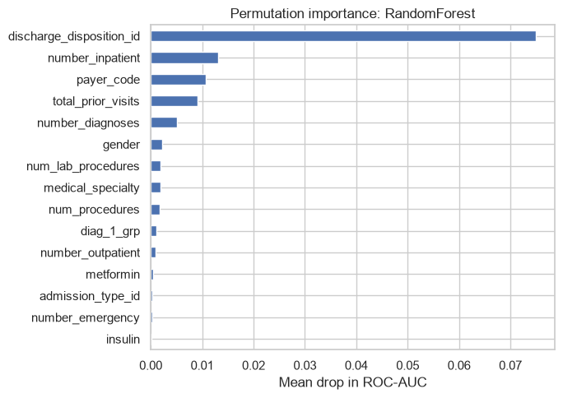
Fig. 7. Permutation importance of the tuned random forest: mean drop in test ROC-AUC when each feature is shuffled. Estimated on 6,000 test rows with five repeats. Discharge disposition dominates.
V. Discussion
A. What the Performance Level Means
A test ROC-AUC of 0.656 sits in the range Kansagara et al. [6] reported for readmission models built from administrative data, where c-statistics of roughly 0.55 to 0.70 are typical. A value of 0.66 means that a patient who returns within 30 days outscores a patient who does not about two times in three. That is better than chance and is not a basis for an automatic decision. Precision of 0.124 at recall of 0.68 means about seven of every eight flagged patients will not return within 30 days, so any action tied to the score has to be cheap, such as a phone call rather than a longer stay.
The learning curves explain why tuning and a deeper network did not break this level. Validation ROC-AUC flattens near 0.65 for the forest and near 0.64 for every network, while training scores keep rising. The bottleneck is the content of the row. Socioeconomic circumstances, whether medicines are taken after discharge, the quality of discharge planning, social support and laboratory trajectories are absent. HbA1c and glucose are missing for most encounters, so they cannot carry the association reported by Strack et al. [5]. A discharge summary of this kind contains only part of what determines a return within 30 days.
B. Traditional Models and Deep Learning
The comparison agrees with the tabular results of Shwartz-Ziv and Armon [8] and Grinsztajn et al. [9]. The forest leads the network by 0.0046 ROC-AUC, and gradient boosting leads it on PR-AUC (0.183 against 0.165). Both gaps are small, the bootstrap intervals overlap, and the practical summary is a tie, with a slight edge to the tree ensembles. One-hot specialty, payer and disposition codes are sparse and mostly weak, and a tree can ignore them while a dense layer must learn to down-weight them [9]. The steep rise in risk after several prior inpatient stays, shown in Fig. 1, is a threshold a split represents directly. Capacity moved the networks in the wrong direction: the deepest Sequential model had the lowest validation AUC, and the winner’s training AUC pulled away from validation within a few epochs. That fits the argument of Gorishniy et al. [10] that regularisation, more than architecture, decides how a multilayer perceptron behaves on tabular data. Dropout and early stopping held validation AUC near 0.64, and residual blocks changed it by less than 0.005.
The forest also has the practical advantage. It saves as one pipeline that includes preprocessing, and permutation importance can be read from it directly. The network needs a separate preprocessor, class weights and early stopping. Given a tie on discrimination, the traditional model is the one to keep.
C. Feature Engineering
The ablation shows only a small benefit from the engineered features, and Fig. 7 explains why. The columns that move ROC-AUC are discharge disposition, prior inpatient visits and payer code, all of which are in the base set. Total prior visits appears just behind them, but a forest can approximate that sum from the raw counts. Diagnosis groups, medication changes and the per-day ratios do not register. The gain in Table IV is best read as a small help to the linear models, which cannot build those combinations themselves. The features are cheap and do no harm, so they are worth keeping, and they are not why the forest reaches 0.656.
D. Errors, Thresholds and Fairness
One F2 threshold protects groups unequally. Recall is 0.47 in the forties and 0.85 over age 90, while the false-positive rate moves from 0.29 to 0.73. Recall is 0.44 after discharge home and 0.97 after discharge to a skilled nursing facility. Used as a queue for follow-up calls, the score would spend most of its alarms on patients already transferred to another level of care, and it would miss more than half of the early readmissions among patients who go home. That allocation is uneven even though the model does not use a sensitive attribute at decision time, in the spirit of the warning from Obermeyer et al. [13]. Race was not audited: it is missing for about 2% of rows, and a race-specific recall would be easy to over-read. A threshold applied only among patients discharged home would be a more honest policy than the single cut in Table VII.
E. Limitations
Several limits bound these conclusions. The encounters date from 1999 to 2008, and coding, medicines and discharge practice have changed, so the fit should not be assumed to hold now. The 130 hospitals are not identified, which prevents a site-held-out test. Keeping the first encounter per patient removes leakage and also removes 29,353 stays; order is inferred from the encounter identifier. A return to a different health system is labelled negative, so the labels are noisy. The RBF SVM used 12,000 rows, the network search covered five configurations, and uncertainty is a bootstrap of one split rather than repeated splits. F2 also encodes a cost ratio that favours recall. A service that can call only a small fraction of discharges would choose a higher threshold and would still be limited by the same ranking quality.
VI. Conclusion
This study compared traditional machine learning and deep learning for predicting 30-day readmission among inpatients with diabetes, using a pipeline that removes patients who cannot be readmitted and keeps one encounter per patient. On 13,998 held-out encounters the tuned random forest reached a ROC-AUC of 0.656 (95% confidence interval 0.640–0.673) and the best neural network, a residual multilayer perceptron trained with tf.data, reached 0.652 (0.636–0.670). The intervals overlap. Histogram gradient boosting recorded the highest PR-AUC, 0.183. Feature engineering raised cross-validated ROC-AUC by only a few thousandths. Learning curves for both paradigms flatten near a validation ROC-AUC of 0.65 while training scores continue to rise, which indicates that more data of the same kind, or a deeper network, will not repair the problem. Error analysis shows uneven recall by age and a strong dependence on discharge destination: patients sent home are missed, and patients sent to a facility are flagged almost without regard to outcome. Tuned tree ensembles remain the appropriate baseline for this tabular clinical task, and the information recorded at discharge, rather than the choice between scikit-learn and Keras, is what limits accuracy.
Future work should add variables the present table does not contain, test the same pipeline on more recent encounters and on hospitals that were not used in training, and choose thresholds inside subgroups, especially among patients discharged home. A prospective study would still be required to learn whether acting on the score reduces readmissions, which no retrospective AUC can answer.
References
[1] S. F. Jencks, M. V. Williams, and E. A. Coleman, “Rehospitalizations among patients in the Medicare fee-for-service program,” N. Engl. J. Med., vol. 360, no. 14, pp. 1418–1428, 2009.
[2] A. D. Auerbach et al., “Preventability and causes of readmissions in a national cohort of general medicine patients,” JAMA Intern. Med., vol. 176, no. 4, pp. 484–493, 2016.
[3] S. Kaufman, S. Rosset, C. Perlich, and O. Stitelman, “Leakage in data mining: Formulation, detection, and avoidance,” ACM Trans. Knowl. Discov. Data, vol. 6, no. 4, pp. 15:1–15:21, 2012.
[4] B. Strack et al., “Diabetes 130-US hospitals for years 1999–2008,” UCI Machine Learning Repository, 2014. [Online]. Available: https://archive.ics.uci.edu/dataset/296
[5] B. Strack et al., “Impact of HbA1c measurement on hospital readmission rates: Analysis of 70,000 clinical database patient records,” BioMed Res. Int., vol. 2014, Art. no. 781670, 2014.
[6] D. Kansagara et al., “Risk prediction models for hospital readmission: A systematic review,” JAMA, vol. 306, no. 15, pp. 1688–1698, 2011.
[7] A. Rajkomar et al., “Scalable and accurate deep learning with electronic health records,” npj Digit. Med., vol. 1, Art. no. 18, 2018.
[8] R. Shwartz-Ziv and A. Armon, “Tabular data: Deep learning is not all you need,” Inf. Fusion, vol. 81, pp. 84–90, 2022.
[9] L. Grinsztajn, E. Oyallon, and G. Varoquaux, “Why do tree-based models still outperform deep learning on typical tabular data?” in Proc. NeurIPS Datasets and Benchmarks Track, 2022.
[10] Y. Gorishniy, I. Rubachev, V. Khrulkov, and A. Babenko, “Revisiting deep learning models for tabular data,” in Proc. NeurIPS, 2021.
[11] J. Davis and M. Goadrich, “The relationship between precision-recall and ROC curves,” in Proc. ICML, 2006, pp. 233–240.
[12] T. Saito and M. Rehmsmeier, “The precision-recall plot is more informative than the ROC plot when evaluating binary classifiers on imbalanced datasets,” PLoS ONE, vol. 10, no. 3, Art. no. e0118432, 2015.
[13] Z. Obermeyer, B. Powers, C. Vogeli, and S. Mullainathan, “Dissecting racial bias in an algorithm used to manage the health of populations,” Science, vol. 366, no. 6464, pp. 447–453, 2019.
[14] F. Pedregosa et al., “Scikit-learn: Machine learning in Python,” J. Mach. Learn. Res., vol. 12, pp. 2825–2830, 2011.
[15] C. Cortes and V. Vapnik, “Support-vector networks,” Mach. Learn., vol. 20, no. 3, pp. 273–297, 1995.
[16] L. Breiman, “Random forests,” Mach. Learn., vol. 45, no. 1, pp. 5–32, 2001.
[17] G. Ke et al., “LightGBM: A highly efficient gradient boosting decision tree,” in Proc. NIPS, 2017, pp. 3146–3154.
[18] J. H. Friedman, “Greedy function approximation: A gradient boosting machine,” Ann. Statist., vol. 29, no. 5, pp. 1189–1232, 2001.
[19] J. Bergstra and Y. Bengio, “Random search for hyper-parameter optimization,” J. Mach. Learn. Res., vol. 13, pp. 281–305, 2012.
[20] M. Abadi et al., “TensorFlow: Large-scale machine learning on heterogeneous systems,” 2015, arXiv:1603.04467.
[21] S. Ioffe and C. Szegedy, “Batch normalization: Accelerating deep network training by reducing internal covariate shift,” in Proc. ICML, 2015, pp. 448–456.
[22] N. Srivastava, G. Hinton, A. Krizhevsky, I. Sutskever, and R. Salakhutdinov, “Dropout: A simple way to prevent neural networks from overfitting,” J. Mach. Learn. Res., vol. 15, pp. 1929–1958, 2014.
[23] K. He, X. Zhang, S. Ren, and J. Sun, “Deep residual learning for image recognition,” in Proc. IEEE CVPR, 2016, pp. 770–778.
[24] D. P. Kingma and J. Ba, “Adam: A method for stochastic optimization,” in Proc. ICLR, 2015.

